4. System Analysis & Design
4.1 Problem Statement & Objectives
Problem Statement
In Egypt, people who lose personal belongings usually depend on scattered Facebook posts, WhatsApp messages, or paper announcements. These methods are unreliable, difficult to search, and provide no secure way to verify ownership. As a result, many lost items never return to their owners.
Objectives
The main objectives of La2eet are:
- Provide a centralized platform for lost and found reports.
- Allow users to search reports by city and category.
- Verify ownership through verification questions.
- Enable secure communication between finder and owner.
- Give administrators full control over moderation and user management.
Use Case Diagram & Descriptions
Actors
- User
  - Register and login.
  - Create lost/found reports.
  - Submit claims.
  - Chat with other users.
  - Manage profile.
- Admin
  - Approve/reject reports.
  - Manage users.
  - Monitor claims and activities.
  - Export reports.
Functional Requirements
- User registration and login.
- Email confirmation.
- Create lost/found reports.
- Upload item images.
- Submit and manage claims.
- Real-time chat.
- Admin moderation dashboard.
Non-Functional Requirements
- Security using ASP.NET Core Identity.
- Real-time performance using SignalR.
- Data consistency in SQL Server.
- Responsive user interface.
- Scalability through layered architecture.
Software Architecture
The system follows a Layered MVC Architecture:
- Presentation Layer: Razor Views.
- Controller Layer: Handles requests.
- Service Layer: Contains business logic.
- Repository Layer: Handles database operations.
- Data Layer: SQL Server with Entity Framework Core.

4.2 Database Design & Data Modeling
ER Diagram
The database consists of five main entities:
- User
- Item
- Claim
- VerificationQuestion
- Message
Relationships
- One User can create many Items.
- One Item can have many Claims.
- One Item can have many Verification Questions.
- One Item can have many Messages.
- One Claim belongs to one User and one Item.
Logical Schema
- Users(Id, FullName, Email, Phone,PasswordHash,EmailConfirmed ,IsVerified, IsBanned , CreatedAt)
- Items(ItemId, Title, Description,ImageBase64 ,City , Location, Status,ReportStatus ,LostOrFoundDate , CreatedAt , UserId)
- Claims(ClaimId, ClaimStatus , VerificationAnswer , CreatedAt ,ItemId, UserId)
- VerificationQuestions(QId, QuestionText , ExpectedAnswerHash , CreatedAt , ItemId)
- Messages(MessageId, SenderId, ReceiverId, IsRead, Content, SentAt)
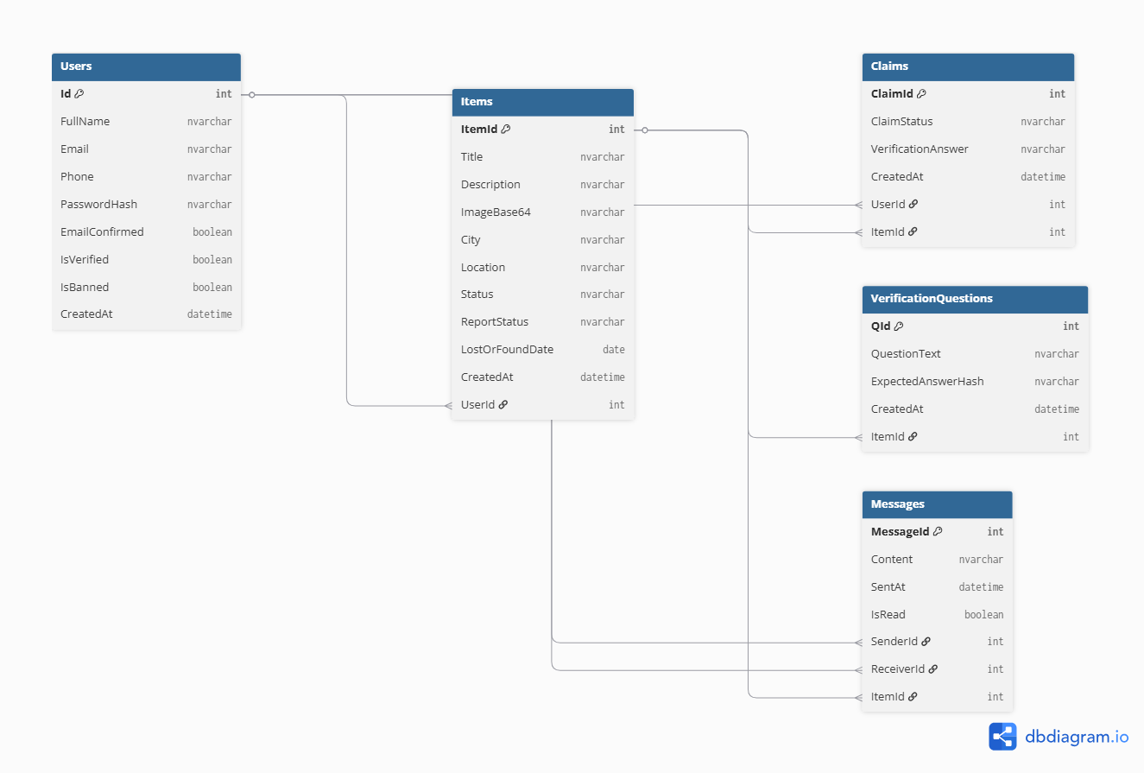

4.3 Data Flow & System Behavior
Data Flow Diagram (DFD)
Level 0
- User sends report/claim.
- System processes request.
- Database stores data.
- Admin reviews reports.
- System returns approved data to users.
Level 1
- User submits report.
- Report stored as Pending.
- Admin approves/rejects report.
- User submits claim.
- Reporter reviews claim.
- Chat opens after approval.
- Item marked as Returned.
Sequence Diagram (Claim Process)
- User selects item.
- User submits claim.
- System stores claim.
- Reporter reviews answers.
- Reporter approves claim.
- System opens SignalR chat.
Activity Diagram
- Register → Login → Browse Items → Submit Claim → Review Claim → Chat → Return Item.
State Diagram (Item)
- Pending → Approved → Claimed → Returned.
Class Diagram
Main classes:
- ApplicationUser
- Item
- Claim
- VerificationQuestion
- Message
Each class contains its attributes and relationships with other classes.

4.4 UI/UX Design & Prototyping
Wireframes & Mockups
Designed screens include:
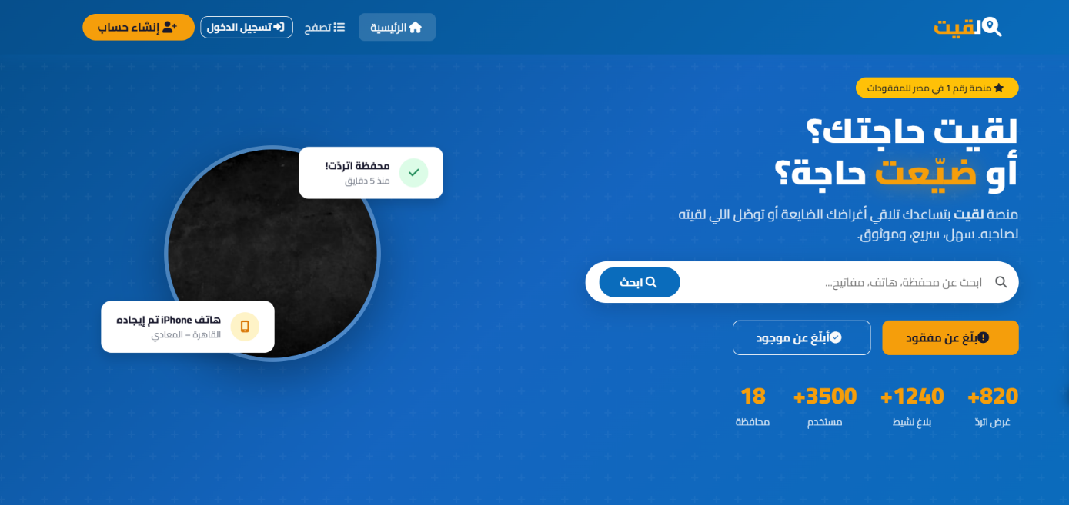
- Home Page

The Home Page provides users with an overview of the platform, including live statistics, approved lost and found reports, search functionality, and quick navigation to the main features.
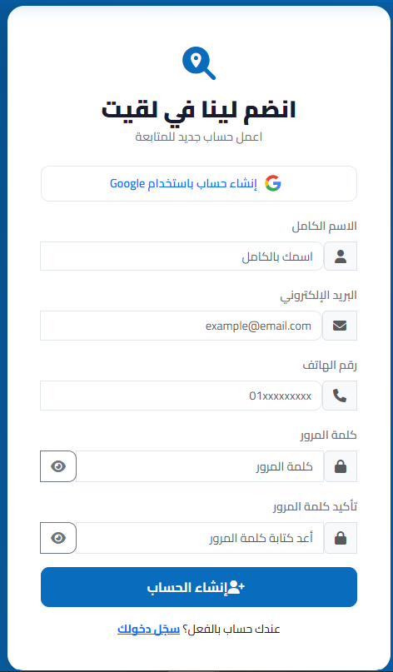
- Register Page

The Register Page enables new users to create an account
by entering their personal information,
with server-side validation and email confirmation.

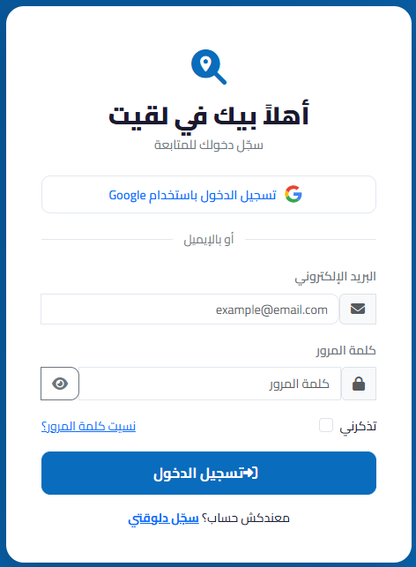
- Login Page

The Login Page allows registered users to securely access
the platform using their email and password or
sign in with their Google account.

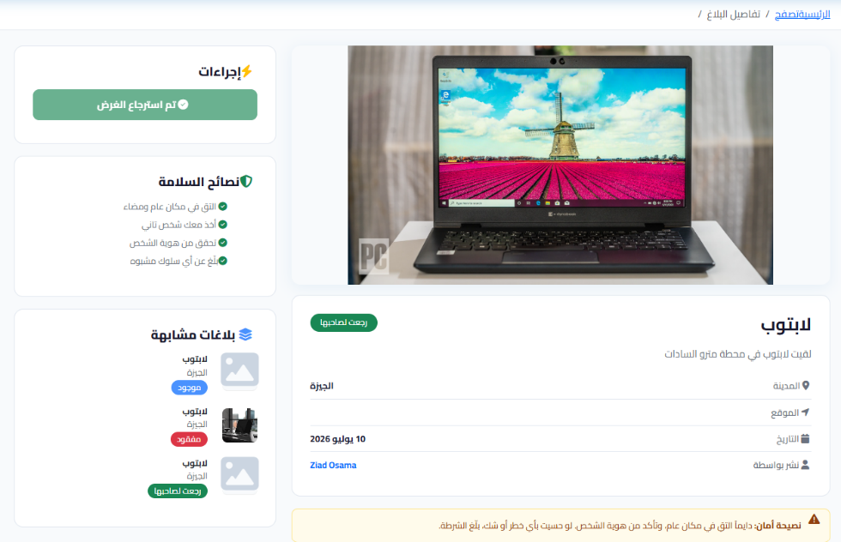
- Item Details

The Item Details Page provides complete
information about a selected item,
including its description, location,
image, and available claim options.

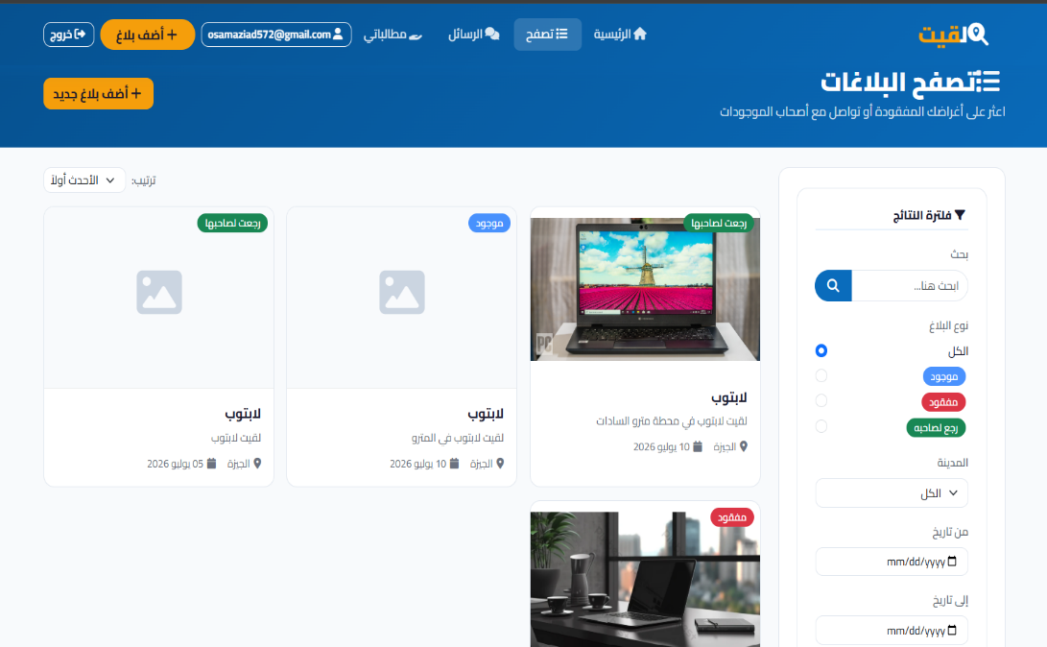
- Browse Items Page

The Browse Items Page displays
all approved lost and found
reports, allowing users to search
and filter items by city or
category.

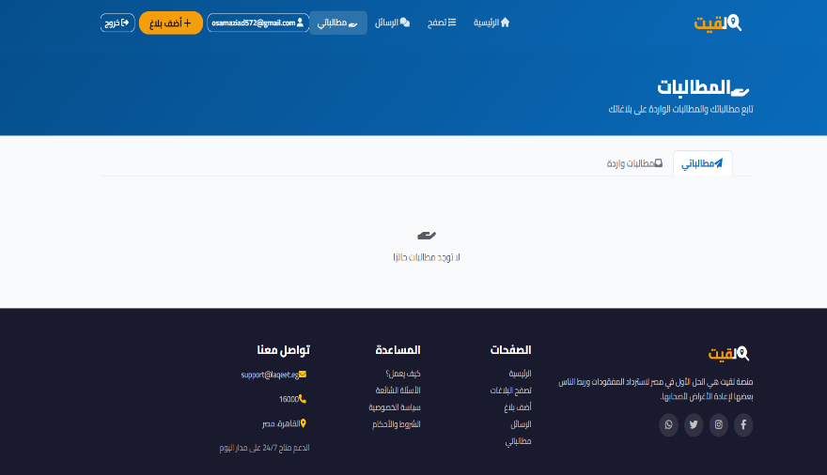
- Claims Dashboard
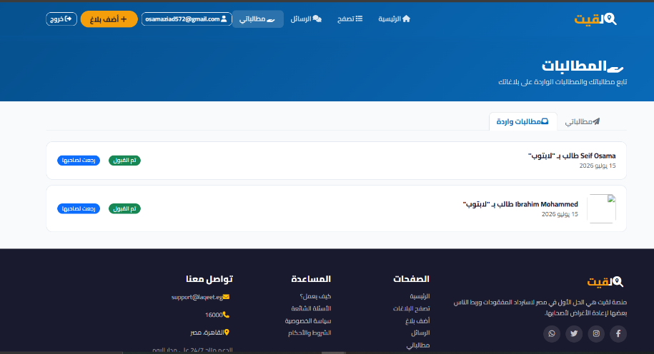

The Claims Page allows users to submit, review, approve, or reject claims through a secure verification process based on predefined questions.
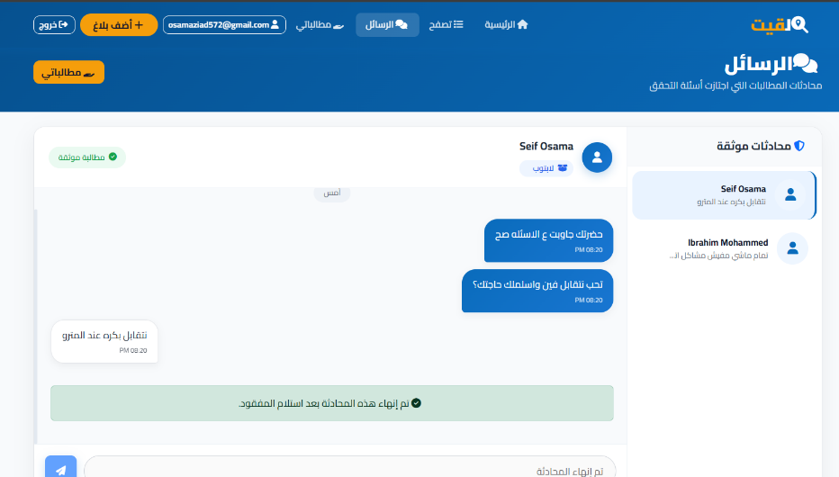
- Chat Page
The Chat Page enables real-time
communication between the finder
and the claimant using SignalR after
a claim has been successfully approved.

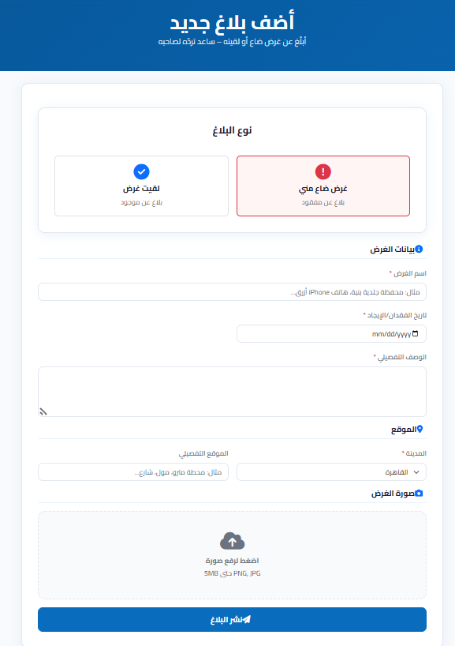
- Create Lost Report Page

The Create Lost Report Page allows users to
report lost items by providing detailed
information such as title, description,
location, city, date, and an optional image.

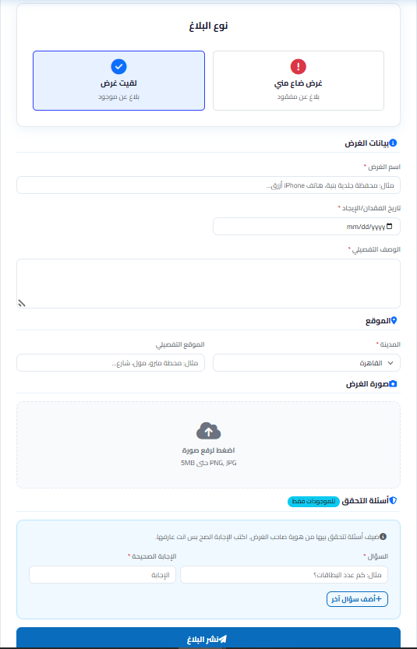
- Create Found Report Page

The Create Found Report Page enables users to
report found items and add verification questions
to help confirm the identity of the rightful owner.

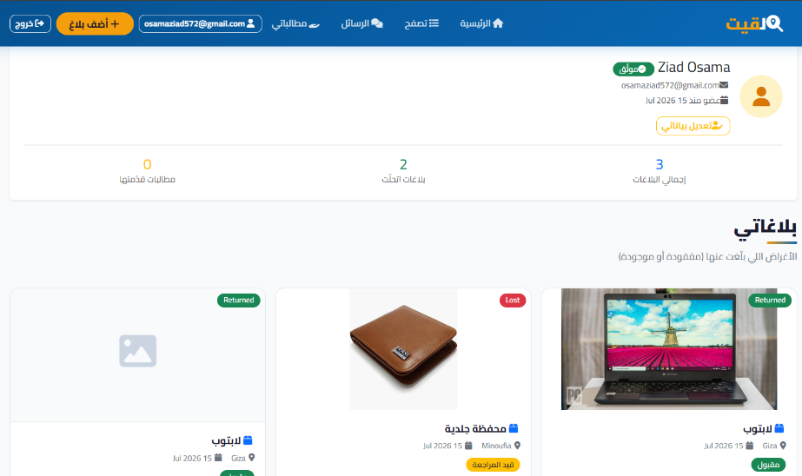
- User Profile Page

The User Profile Page displays the user's
personal information, report history,
claim history, and account statistics,
with options to update profile details.

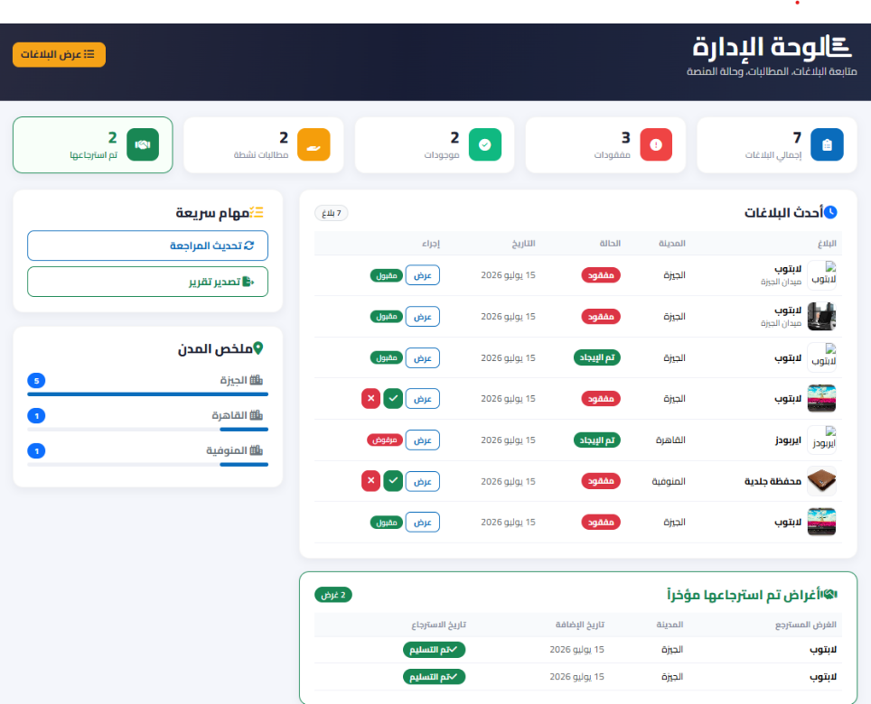
- Admin Dashboard

The Admin Dashboard provides
administrators with full control over
the platform, including report moderation,
user management, claim monitoring,
system statistics, and data export.

4.2 UI/UX Guidelines

Design Principles
- Clarity first: every screen has a single primary action, clearly emphasized over secondary ones
- Trust by design: safety tips, verification steps, and status badges are always visible to reduce fraud risk
- Consistency: the same card, badge, and button styles are reused across Home, Browse, and Claims screens
- Feedback: every action (submit, approve, reject, send) shows an immediate success/error message
- Localization-first: designed natively for Arabic/RTL rather than mirrored from an English layout

Color Scheme
Swatch | Hex | Name | Usage
 | #0B4F8C | Primary Blue | Navbar, primary buttons, links, headings
 | #F5A623 | Accent Orange | Highlights, 'Add report' CTA, badges
 | #28A745 | Success Green | Approved / Returned status, success alerts
 | #DC3545 | Danger Red | Rejected / Banned status, error alerts
 | #FFC107 | Warning Yellow | Pending status badges
 | #F8F9FA | Neutral Background | Page and card backgrounds
 | #212529 | Text Dark | Primary body text

Typography
Element | Font | Notes
Headings | Cairo, Bold | Clear Arabic display font, strong visual hierarchy
Body text | Cairo, Regular | High legibility at small sizes for descriptions and forms
Buttons / Labels | Cairo, SemiBold | Slightly heavier weight to stand out as actionable

Layout & Components
- Built on Bootstrap 5 grid system for consistent responsiveness across breakpoints
- Card-based layout for reports, claims, and admin tables
- Font Awesome icons used consistently for actions (claim, chat, approve, reject, export)
- Status badges use consistent color coding across the whole app (see Color Scheme table)

Accessibility Considerations
- Sufficient color contrast between text and backgrounds (validated against WCAG AA where possible)
- All form fields have visible labels, not placeholder-only text
- Field-level error messages are announced next to their input, not only in a top-level summary
- Interactive elements (buttons, links) have adequate touch target size for mobile users
- RTL layout mirrors all directional icons (arrows, chevrons) to match reading direction

4.5 System Deployment & Integration
Technology Stack
- Backend: ASP.NET Core MVC (.NET 9)
- Database: SQL Server
- ORM: Entity Framework Core
- Authentication: ASP.NET Core Identity
- Real-Time Communication: SignalR
- Email Service: MailKit SMTP
Deployment Diagram
- Client Browser
- ASP.NET Core Web Server
- SQL Server Database
- SMTP Email Service
Component Diagram
Main components:
- Authentication Module
- Item Management Module
- Claims Module
- Chat Module
- Admin Module
- Database Module

